ScoutIQ — Intelligent Football Player Scouting System
DBMS Experiential Learning Level 3 · Project Report · Oct 26, 2026 · @Amaan Ahmed

1. Objectives
ScoutIQ helps a football club's scouting department record, search and act on player assessments. At Level 3 it combines a relational database for structured scouting data with a vector database for meaning-based search over scouts' written reports.
- Centralise scouting data. Keep players, clubs, per-season statistics and match reports in one consistent PostgreSQL database instead of scattered notes and spreadsheets.
- Find players by description, not keywords. Let a scout type "quick wide player who presses from the front" and retrieve reports that mean this, even when they use different words, using pgvector embeddings and cosine similarity.
- Support the recruitment decision workflow. Scouts recommend signings; admins approve or reject them. The database enforces who can do what and which status changes are allowed.
- Enforce integrity at the database level. Use keys, CHECK constraints, triggers and stored procedures so that invalid data is rejected no matter which client writes it.
- Keep an auditable history. Record every change to players, reports and recommendations, with the user who made it.
- Turn raw data into rankings. Provide a composite scouting score, latest-season summaries, club aggregates and similar-player suggestions through views and functions.
- Demonstrate advanced DBMS concepts in a working full-stack application. Cover transactions, stored procedures, triggers, views, indexing, full-text search and vector similarity search, exposed through a Next.js interface with role-based access.

2. Functional requirements
The system has two roles: Scout and Admin. Every requirement below is enforced in the API, and where marked (DB), also by the database itself.

2.1 Common to both roles
ID | Requirement
FR-1 | Sign in with a username and password; passwords are stored only as bcrypt hashes.
FR-2 | Browse all players with their club, latest-season statistics, average scout rating, market value and composite score.
FR-3 | Filter players by name, position, club and maximum age; sort by score, goals, assists, rating, value, age or name.
FR-4 | View a player's profile: season-by-season statistics, all scouting reports, and the five most similar players.
FR-5 | Search scouting reports in two modes: semantic (vector similarity) and keyword (full-text), optionally filtered by position and age.
FR-6 | Maintain a personal shortlist: add or remove players, with a priority from 1 to 5 and notes. A player cannot be shortlisted twice by the same user (DB).
FR-7 | File a scouting report on a player: match date, opponent, rating 1–10, strengths, weaknesses and a summary of at least 30 characters (DB). The report is embedded automatically when saved.

2.2 Scout
ID | Requirement
FR-8 | Recommend a player for signing, with a priority (low, medium, high) and a justification of at least 50 characters (DB).
FR-9 | Have at most one pending recommendation per player at a time (DB).
FR-10 | View own recommendations and their outcomes, and withdraw a pending one.

2.3 Admin
ID | Requirement
FR-11 | Review the approval queue, ordered by priority then date.
FR-12 | Approve or reject a pending recommendation with a note. Approval also adds the player to the scout's shortlist at top priority, in one transaction (DB).
FR-13 | Add a player together with their first season of statistics, atomically (DB).
FR-14 | Update or delete players; deletion removes their statistics, reports, shortlist entries and recommendations (DB).
FR-15 | View a dashboard: totals, club aggregates, per-scout activity and approval rate, and the recent audit log.

2.4 System rules
ID | Requirement
FR-16 | Unauthenticated users are redirected to the login page; scouts cannot reach admin pages or endpoints.
FR-17 | Only scouts can create recommendations, only admins can decide them, and a decided recommendation can never change again (DB).
FR-18 | A report's match date cannot be in the future (DB).
FR-19 | Every insert, update and delete on players, reports and recommendations is logged with the acting user (DB).
FR-20 | Editing a report's text clears its embedding so it is re-embedded; stale vectors are never searched (DB).

3. ER diagram
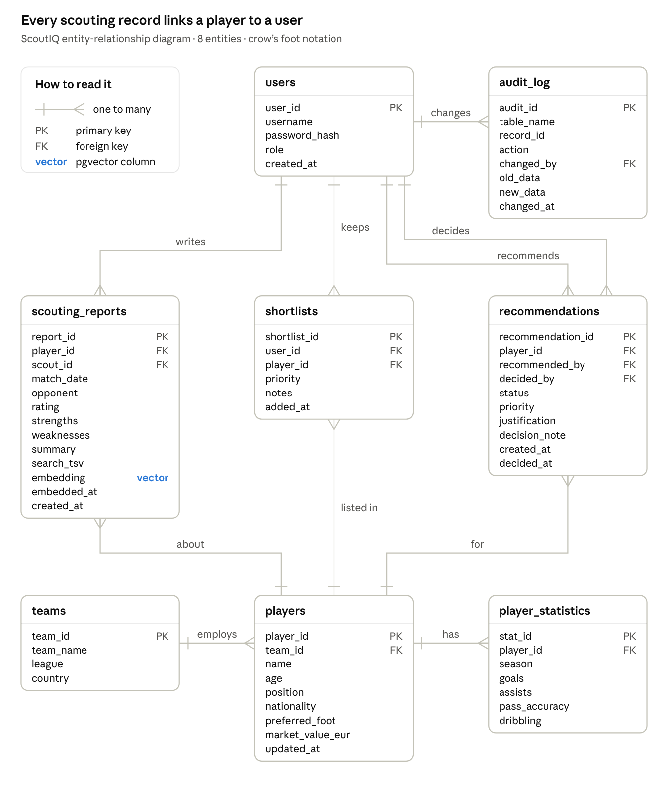
ScoutIQ ER diagram · 8 entities, 10 one-to-many relationships
Players and users are the two hubs. Every scouting report, shortlist entry and recommendation joins one player to one user, so shortlists also resolve the many-to-many relationship between users and players. Recommendations link to users twice: once for the scout who recommends and once for the admin who decides. Full attribute details are in Section 6.

4. Relational schema
The schema has eight relations. Primary keys are bold; arrows mark foreign keys and the relation they reference.
- users(user_id, username, password_hash, role, created_at)
- teams(team_id, team_name, league, country)
- players(player_id, team_id → teams, name, age, position, nationality, preferred_foot, market_value_eur, updated_at)
- player_statistics(stat_id, player_id → players, season, goals, assists, pass_accuracy, dribbling)
- scouting_reports(report_id, player_id → players, scout_id → users, match_date, opponent, rating, strengths, weaknesses, summary, search_tsv, embedding, embedded_at)
- shortlists(shortlist_id, user_id → users, player_id → players, priority, notes, added_at)
- recommendations(recommendation_id, player_id → players, recommended_by → users, decided_by → users, status, priority, justification, decision_note, created_at, decided_at)
- audit_log(audit_id, table_name, record_id, action, changed_by → users, old_data, new_data, changed_at)

4.1 Candidate keys beyond the primary key
Relation | Unique key | Meaning
users | (username) | One account per login name
teams | (team_name) | Club names are unique
player_statistics | (player_id, season) | One statistics row per player per season
shortlists | (user_id, player_id) | A user shortlists a player at most once
recommendations | (player_id, recommended_by) where status = 'pending' | At most one open recommendation per scout per player (partial unique index)

4.2 Foreign keys and referential actions
Foreign key | References | On delete | Reason
players.team_id | teams.team_id | SET NULL | A club being removed leaves its players as free agents
player_statistics.player_id | players.player_id | CASCADE | Statistics have no meaning without the player
scouting_reports.player_id | players.player_id | CASCADE | Reports belong to the player
scouting_reports.scout_id | users.user_id | SET NULL | Keep the report if the scout's account is removed
shortlists.user_id | users.user_id | CASCADE | A user's shortlist goes with the user
shortlists.player_id | players.player_id | CASCADE | Remove the entry when the player is removed
recommendations.player_id | players.player_id | CASCADE | Recommendation is about that player
recommendations.recommended_by | users.user_id | RESTRICT | A scout with recommendation history cannot be deleted
recommendations.decided_by | users.user_id | SET NULL | The decision stays even if the admin account goes
audit_log.changed_by | users.user_id | SET NULL | History survives account removal

4.3 Normalisation
All relations are in 3NF. Each column holds one atomic value (1NF). Season statistics depend on (player, season), not on the player alone, so they sit in player_statistics instead of repeating player details per season (2NF). Club name and league live only in teams, so changing a club's league is one update (3NF). Reports, shortlists and recommendations are separate relations because each has its own key and its own attributes.

5. Database choice and justification
ScoutIQ uses PostgreSQL 16 as the relational database and pgvector as the vector database, running as an extension inside the same PostgreSQL instance.

5.1 Why a relational database (PostgreSQL)
Most ScoutIQ data is structured, with fixed attributes and relationships that must stay consistent: users, clubs, players, season statistics, shortlists and recommendations.
- Integrity: foreign keys, CHECK constraints and UNIQUE constraints reject invalid data at the source, for example an age of 52 or a duplicate season row.
- Relationships and queries: joins, GROUP BY, HAVING, subqueries and window functions answer questions such as "average score per club" directly.
- Transactions: approving a recommendation updates two tables; ACID transactions guarantee both changes happen or neither does.
- Procedural logic: triggers and stored procedures enforce business rules (the recommendation state machine, the audit trail) for every client, not only the web app.
- Built-in full-text search: tsvector columns with GIN indexes give ranked keyword search without a separate search engine.

5.2 Why a vector database (pgvector)
Scouting reports are free text, and scouts describe the same trait in different words: "pacy", "explosive acceleration", "quick over ten yards". Keyword search misses these synonyms.
- Each report is converted into a 384-dimensional embedding by the all-MiniLM-L6-v2 sentence-transformer model. Texts with similar meaning get vectors that are close together.
- A search query is embedded the same way, and reports are ranked by cosine distance (the <=> operator), using an HNSW index for fast approximate nearest-neighbour search.
- Averaging a player's report vectors gives a "profile vector", which finds players with a similar playing style.

5.3 Why pgvector rather than a separate vector store
Consideration | pgvector (chosen) | Separate store (e.g. Pinecone, Qdrant)
Semantic search with SQL filters | One query: vector ranking + WHERE + JOIN ("similar to player X, under 23, under €20M") | Filter metadata must be copied into the vector store, or results joined in application code
Consistency | Vectors live in the same row and transaction as the report; deleting a player cascades to its vectors | Two systems to keep in sync; deletes and edits can leave orphaned vectors
Operations | One server, one connection string, one backup | A second service, account and credentials
Scale | Suited to this project's size (thousands of reports) | Built for hundreds of millions of vectors, which this project does not need

5.4 Why not MongoDB
The brief allows MongoDB as the second database. ScoutIQ's report data has a fixed structure (rating, date, opponent, strengths, weaknesses, summary) that relational columns already model well. What a document store would add, flexible schema, the project does not need. What the project does need, meaning-based search combined with relational filters and transactions, pgvector provides inside the database that already holds the relational data.

6. Data dictionary
PK = primary key, FK = foreign key, NN = NOT NULL, UQ = UNIQUE. All timestamps default to the time the row is written.

6.1 users
Login accounts for scouts and admins.
Column | Type | Constraints | Description
user_id | SERIAL | PK | Unique user identifier
username | VARCHAR(50) | NN, UQ, CHECK lowercase letters, digits or _ (3–50 chars) | Login name
password_hash | VARCHAR(255) | NN | bcrypt hash; plain passwords are never stored
role | VARCHAR(10) | NN, CHECK IN ('scout','admin') | Decides permissions
created_at | TIMESTAMP | NN, DEFAULT NOW() | Account creation time

6.2 teams
Football clubs.
Column | Type | Constraints | Description
team_id | SERIAL | PK | Unique club identifier
team_name | VARCHAR(100) | NN, UQ | Club name
league | VARCHAR(100) | — | League the club plays in
country | VARCHAR(100) | — | Country of the club

6.3 players
Footballers being scouted.
Column | Type | Constraints | Description
player_id | SERIAL | PK | Unique player identifier
team_id | INT | FK → teams, ON DELETE SET NULL | Current club; NULL = free agent
name | VARCHAR(100) | NN | Full name
age | INT | CHECK 15–45 | Age in years
position | VARCHAR(30) | NN | Playing position, e.g. Winger
nationality | VARCHAR(56) | — | Nationality
preferred_foot | VARCHAR(5) | CHECK IN ('Left','Right','Both') | Dominant foot
market_value_eur | NUMERIC(12,0) | CHECK ≥ 0 | Estimated transfer value in euros
updated_at | TIMESTAMP | NN, set by trigger on every update | Last modification time

6.4 player_statistics
One row of performance numbers per player per season.
Column | Type | Constraints | Description
stat_id | SERIAL | PK | Unique row identifier
player_id | INT | NN, FK → players, ON DELETE CASCADE | Player the stats belong to
season | VARCHAR(10) | NN, CHECK format YYYY-YY, UQ with player_id | Season, e.g. 2025-26
goals | INT | NN, DEFAULT 0, CHECK ≥ 0 | Goals scored
assists | INT | NN, DEFAULT 0, CHECK ≥ 0 | Assists made
pass_accuracy | DECIMAL(5,2) | CHECK 0–100 | Pass completion, %
dribbling | INT | CHECK 0–100 | Dribbling rating

6.5 scouting_reports
Match reports written by scouts. Holds both the full-text and the vector representation of the text.
Column | Type | Constraints | Description
report_id | SERIAL | PK | Unique report identifier
player_id | INT | NN, FK → players, ON DELETE CASCADE | Player observed
scout_id | INT | FK → users, ON DELETE SET NULL | Scout who wrote it
match_date | DATE | trigger: not in the future | Date of the match watched
opponent | VARCHAR(100) | — | Opposing team
rating | SMALLINT | CHECK 1–10 | Scout's overall rating
strengths | TEXT | — | Observed strengths
weaknesses | TEXT | — | Observed weaknesses
summary | TEXT | NN, CHECK at least 30 characters | Main assessment
search_tsv | TSVECTOR | generated from summary, strengths, weaknesses; GIN index | Weighted full-text search document
embedding | VECTOR(384) | HNSW index (cosine); cleared by trigger when text changes | Semantic embedding of the report
embedded_at | TIMESTAMP | — | When the embedding was computed
created_at | TIMESTAMP | NN, DEFAULT NOW() | When the report was filed

6.6 shortlists
Players each user is tracking (resolves the many-to-many between users and players).
Column | Type | Constraints | Description
shortlist_id | SERIAL | PK | Unique entry identifier
user_id | INT | NN, FK → users, ON DELETE CASCADE, UQ with player_id | Owner of the shortlist
player_id | INT | NN, FK → players, ON DELETE CASCADE | Player shortlisted
priority | SMALLINT | NN, DEFAULT 3, CHECK 1–5 | 1 = most urgent
notes | TEXT | — | Free notes
added_at | TIMESTAMP | NN, DEFAULT NOW() | When the player was added

6.7 recommendations
Scout proposals to sign a player, decided by an admin.
Column | Type | Constraints | Description
recommendation_id | SERIAL | PK | Unique recommendation identifier
player_id | INT | NN, FK → players, ON DELETE CASCADE | Player recommended
recommended_by | INT | NN, FK → users, ON DELETE RESTRICT; trigger: must be a scout | Scout who recommends
decided_by | INT | FK → users, ON DELETE SET NULL; trigger: must be an admin | Admin who decided
status | VARCHAR(10) | NN, DEFAULT 'pending', CHECK IN ('pending','approved','rejected','withdrawn'); trigger: final once decided | Workflow state
priority | VARCHAR(6) | NN, DEFAULT 'medium', CHECK IN ('low','medium','high') | Urgency
justification | TEXT | NN, CHECK at least 50 characters; trigger: cannot be edited | Scout's reasoning
decision_note | TEXT | — | Admin's comment
created_at | TIMESTAMP | NN, DEFAULT NOW() | Submission time
decided_at | TIMESTAMP | CHECK set exactly when status is not pending, and not before created_at | Decision time

6.8 audit_log
Change history, written only by triggers.
Column | Type | Constraints | Description
audit_id | BIGSERIAL | PK | Unique entry identifier
table_name | VARCHAR(50) | NN | Table that changed
record_id | INT | NN | Primary key of the changed row
action | VARCHAR(6) | NN, CHECK IN ('INSERT','UPDATE','DELETE') | Kind of change
changed_by | INT | FK → users, ON DELETE SET NULL | User who made the change; NULL for scripts
old_data | JSONB | — | Row before the change
new_data | JSONB | — | Row after the change
changed_at | TIMESTAMP | NN, DEFAULT NOW() | Time of the change

7. Work split
The work is split by feature, top to bottom, so each person owns both database objects and the app code that uses them, and can explain and modify them in the viva. Ayaan owns players, statistics, analytics and access control. Atiksh owns scouting reports, search and the recommendation workflow.

7.1 Starter code each person owns
Each person must be able to explain every line of these files and change them live.
Area | Ayaan | Atiksh
Tables | users, teams, players, player_statistics, shortlists (001_core_schema.sql) | scouting_reports, recommendations, audit_log, ALTER/DROP changes, indexes (002_level3_extension.sql)
Functions and procedures | fn_player_score, sp_add_player_with_stats | fn_similar_players, sp_decide_recommendation, current_app_user
Views | player_summary, scout_activity | pending_recommendations
Triggers | trg_players_updated_at | audit, report validation, recommendation rules (005_triggers.sql)
Search | Name filters and sorting on the players list | Full-text search (tsvector, GIN) and vector search (pgvector, HNSW, embeddings)
API routes | auth, players, teams, shortlist, admin overview | search, reports, recommendations
Shared code | lib/db.ts, lib/auth.ts, proxy.ts, lib/validation.ts | lib/embedder.mjs, lib/api.ts (error mapping), scripts/embed-reports.mjs
Pages | Login, players list, player stats and profile, shortlist, admin dashboard | Search, report form and list, recommend form, my recommendations, admin approval queue
Data and tests | db/seed.sql | db/tests.sql

7.2 New features to implement
These are not in the starter code. Each one touches the database and the app, so each counts as that person's own contribution.
Ayaan
- ☐ Admin "Add player" form. A form on the admin page that calls the existing POST /api/players and sp_add_player_with_stats. Show the database's error when a CHECK fails, for example age 50.
- ☐ Edit and delete players. Edit club, age, position and market value, and delete a player, from the player page (admin only). Use the existing PATCH and DELETE routes and show that the delete cascades.
- ☐ Add a new season of statistics. New POST /api/players/:id/stats route and a form on the player page. A duplicate season must return the uq_player_season error.
- ☐ Position leaderboard. New view position_leaderboard using RANK() OVER (PARTITION BY position ORDER BY score DESC), plus a page showing the top 3 per position.
- ☐ Edit shortlist entries. New PATCH /api/shortlist route to change priority (1–5) and notes, with inline editing on the shortlist page.
- ☐ Write the tests for all of the above in db/tests.sql, continuing from T31.
Atiksh
- ☐ Edit and delete own reports. New PATCH and DELETE /api/reports/:id routes; a scout can change only their own reports. Show that editing clears the embedding (existing trigger) and that the route re-embeds it.
- ☐ Hybrid similarity search. New route and UI on the player page: "similar players, under age X and under value Y", combining fn_similar_players with SQL filters (query Q9 in db/queries.sql).
- ☐ Audit log page. Admin page listing audit_log entries, filtered by table and user, showing old and new values side by side from the JSONB columns.
- ☐ Report edit window. New trigger: a scout can edit a report only within 7 days of filing it; admins are exempt. Raise a clear error message.
- ☐ Compare search modes. On the search page, show semantic and keyword results side by side for the same query, to demonstrate the difference in the viva.
- ☐ Write the tests for all of the above in db/tests.sql, continuing after Ayaan's numbers.

7.3 Shared work
Task | Owner
Create the public GitHub repo, add the other as collaborator, push the base files | Ayaan
Run the README setup from a fresh clone on their own laptop and fix any gaps | Atiksh
Report sections 1, 2, 4, and data dictionary 6.1–6.4, 6.6 | Ayaan
Report sections 3, 5, and data dictionary 6.5, 6.7, 6.8 | Atiksh
Demo script: who presents which feature | Both, each presents their own features
Each person commits their own work from their own GitHub account, in small commits on a feature branch, merged by pull request.

